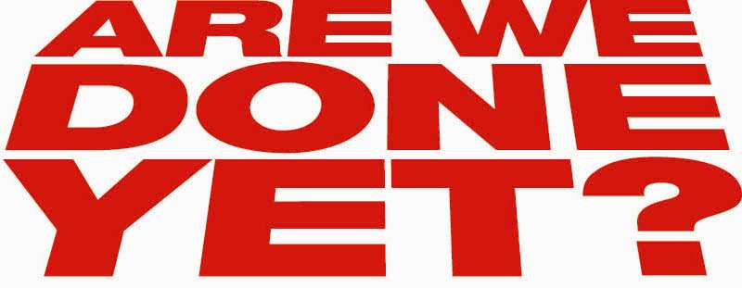

CN-097-18A – Ice Cube stars in Columbia Pictures’/Revolution Studios’ Are We Done Yet?.

CN-182-07A – Nia Long stars in Columbia Pictures’/Revolution Studios’ Are We Done Yet?.

CN-061-09 – John C. McGinley stars in Columbia Pictures’/Revolution Studios’ Are We Done Yet?.

CN-168-20 – Aleisha Allen (left) and Philip Daniel Bolden (right) star in Columbia Pictures’/Revolution Studios’ Are We Done Yet?.

CN-031-12 – Philip Daniel Bolden (left) and Aleisha Allen (right) star in Columbia Pictures’/Revolution Studios’ Are We Done Yet?.

CN-141-05 – John C. McGinley (left) and Ice Cube (right) star in Columbia Pictures’/Revolution Studios’ Are We Done Yet?.

CN-194-36 – John C. McGinley (left) and Ice Cube (right) star in Columbia Pictures’/Revolution Studios’ Are We Done Yet?.

CN-276-23 – Ice Cube (left) and Philip Daniel Bolden (right) star in Columbia Pictures’/Revolution Studios’ Are We Done Yet?.

DF-02439 – Philip Daniel Bolden (left) and Ice Cube (right) star in Columbia Pictures’/Revolution Studios’ Are We Done Yet?.

CN-282-11 – Aleisha Allen (left) and Ice Cube (right) star in Columbia Pictures’/Revolution Studios’ Are We Done Yet?.

DF-00747_r – Aleisha Allen (left), Philip Daniel Bolden (center), and Ice Cube (right) star in Columbia Pictures’/Revolution Studios’ Are We Done Yet?.

CN-204-15 – Philip Daniel Bolden (left), John C. McGinley (center), and Ice Cube (right) star in Columbia Pictures’/Revolution Studios’ Are We Done Yet?.

CN-271-19A – John C. McGinley (left), Nia Long (center), and Ice Cube (right) star in Columbia Pictures’/Revolution Studios’ Are We Done Yet?.

CN-129-03 – (clockwise from left) Nia Long, Aleisha Allen, Ice Cube, and Philip Daniel Bolden star in Columbia Pictures’/Revolution Studios’ Are We Done Yet?.

CN-084-16 – (left to right) Aleisha Allen, Nia Long, Philip Daniel Bolden, and Ice Cube star in Columbia Pictures’/Revolution Studios’ Are We Done Yet?.

DF-02586 – (left to right) Nia Long, Ice Cube, Aleisha Allen, and Philip Daniel Bolden star in Columbia Pictures’/Revolution Studios’ Are We Done Yet?.

CN-041-14 – (left to right) Ice Cube, Nia Long, John C. McGinley, Philip Daniel Bolden, and Aleisha Allen star in Columbia Pictures’/Revolution Studios’ Are We Done Yet?.

DF-00423 – John C. McGinley (left) and Director/Executive Producer Steve Carr (right) on the set of Columbia Pictures’/Revolution Studios’ Are We Done Yet?.

DF-01929 – John C. McGinley (left), Executive Producer Ice Cube (center), and Director/Executive Producer Steve Carr (right) on the set of Columbia Pictures’/Revolution Studios’ Are We Done Yet?.

DF-03279_r – (left to right) Executive Producer Ice Cube, Director/Executive Producer Steve Carr, Producer Matt Alvarez, Producer Todd Garner, and Nia Long on the set of Columbia Pictures’/Revolution Studios’ Are We Done Yet?.

Photo Credit : Rob McEwan

